LexiFlow
LangChain Training Guide
for Freshers
What is LangChain? What is an LLM? How LexiFlow uses LangChain?
With Python file mapping, code examples, diagrams, and fresher-friendly explanations

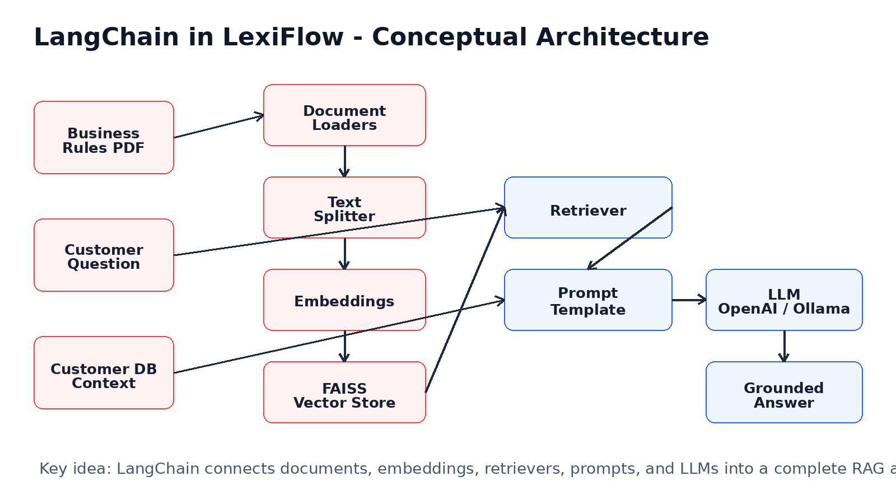

A. Learning Outcomes
- Understand what an LLM is and why it is not enough alone.
- Understand what LangChain is and why developers use it.
- Understand how LexiFlow uses LangChain for RAG.
- Understand the role of document loaders, text splitters, embeddings, FAISS, retrievers, prompt templates, and LLMs.
- Identify the Python files in LexiFlow that implement LangChain concepts.
- Explain the end-to-end flow from customer question to grounded answer.
Important correction
LexiFlow currently uses LangChain, not LangGraph. LangGraph can be a future enhancement for stateful agent orchestration, but the current RAG implementation is LangChain-based.

1. What is an LLM?
LLM stands for Large Language Model. It is an AI model trained on large amounts of text so it can understand language, generate answers, summarize content, translate text, write code, and reason over prompts.
For freshers, think of an LLM as a very advanced text engine. You give it a prompt, and it predicts a useful response based on language patterns and knowledge learned during training.

1.1. Simple example
User: What is the capital of India?
LLM: New Delhi.

1.2. Why LLM alone is not enough
An LLM does not automatically know your latest company policies, order records, warranty status, or customer history. If we ask a policy-specific question directly, the model may guess. This is dangerous in customer support because wrong policy answers can create business problems.
Freshers note
LLM alone gives general intelligence. LangChain helps connect that intelligence with documents, databases, tools, and workflows.

2. What is LangChain?
LangChain is a Python framework for building LLM-powered applications. It provides reusable building blocks to connect LLMs with external knowledge, documents, retrievers, vector databases, prompts, memory, and tools.
A simple comparison: Spring Boot helps Java developers build web applications. LangChain helps AI developers build LLM applications.

2.1. Why developers use LangChain
- Load documents such as PDFs and websites.
- Split large documents into smaller chunks.
- Convert text into embeddings.
- Store embeddings in vector databases like FAISS.
- Retrieve relevant knowledge for a user question.
- Build prompts that combine question + context.
- Call LLMs such as OpenAI or local Ollama models.
- Return answers with source documents.

3. Why LexiFlow Uses LangChain
LexiFlow is an AI customer support demo. It must answer customer questions using company policy documents and customer order context. A direct LLM call cannot reliably do this. LangChain provides the structure to build a RAG pipeline.
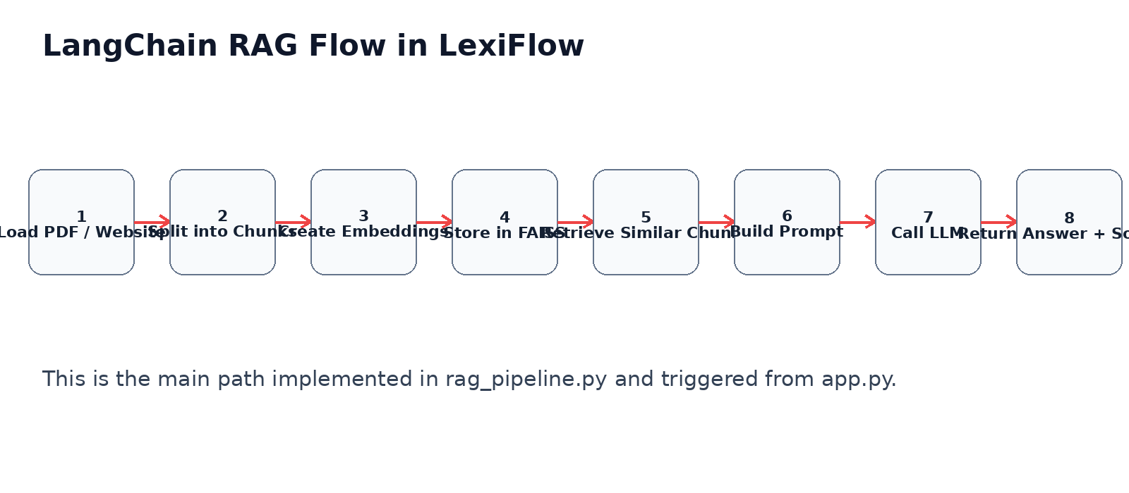

3.1. Main reasons
Reason | Explanation
Policy-grounded answers | LangChain helps retrieve only the relevant parts of the business rules document before answering.
Reusable RAG pipeline | The same RAGPipeline class can load PDFs, websites, split text, create vector DB, retrieve and query.
OpenAI and Ollama support | LexiFlow supports cloud LLMs through OpenAI and local LLMs through Ollama.
Source visibility | Retrieved chunks can be displayed below answers so judges can see grounding.
Cleaner architecture | Instead of writing everything manually, LangChain provides standard components.

4. LangChain Components Used in LexiFlow
Component | Purpose | LexiFlow Usage
Document Loader | Reads PDF pages and website content into LangChain Document objects. | PyPDFLoader, WebBaseLoader
Text Splitter | Breaks long text into smaller chunks for retrieval. | RecursiveCharacterTextSplitter
Embeddings | Converts text chunks into numerical vectors. | OpenAIEmbeddings, HuggingFaceEmbeddings
Vector Store | Stores vectors and allows similarity search. | FAISS
Retriever | Finds relevant chunks for a user question. | FAISS retriever / similarity_search_with_score
Prompt Template | Combines instructions, context, and question. | PromptTemplate, ChatPromptTemplate
LLM Wrapper | Calls the model and returns generated text. | ChatOpenAI, OllamaLLM
Chain | Connects retriever, prompt, LLM, and output parser. | RetrievalQA / LCEL chain

5. Python Files Used to Implement LangChain Concepts
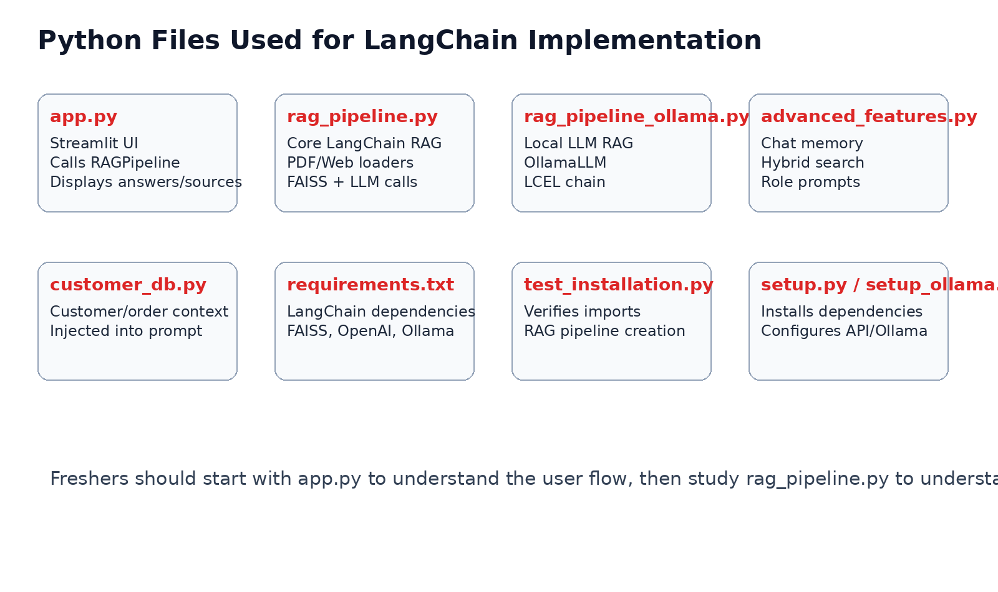
File | How it supports LangChain / LLM usage
requirements.txt | Defines required packages such as langchain, langchain-community, langchain-openai, langchain-ollama, langchain-text-splitters, faiss-cpu, streamlit, pypdf, and sentence-transformers.
app.py | Streamlit UI. It imports RAGPipeline, initializes the pipeline, handles PDF upload, customer lookup, question submission, and displays answers and source chunks.
rag_pipeline.py | Main LangChain implementation. It loads PDFs/websites, splits documents, creates FAISS vector DB, performs similarity search, builds prompt, calls LLM, and returns answer plus sources.
rag_pipeline_ollama.py | Alternative local RAG pipeline using OllamaLLM, HuggingFaceEmbeddings, FAISS, ChatPromptTemplate, RunnablePassthrough, and StrOutputParser.
advanced_features.py | Adds supporting features such as chat memory, hybrid search, role-based prompts, and source citation utilities.
customer_db.py | Not a LangChain file, but provides customer/order/warranty context that is added to the prompt used by LangChain.
test_installation.py | Verifies LangChain-related imports and checks whether RAGPipeline can be instantiated.
setup.py | Installs dependencies and helps configure environment variables for OpenAI.
setup_ollama.py | Sets up local Ollama dependencies and model download for local LLM usage.
examples.py | Contains examples for basic PDF chatbot, multi-document processing, website loading, persistence, hybrid search, and interview explanation.

6. Deep Dive: rag_pipeline.py
This is the most important file for understanding LangChain in LexiFlow. Freshers should spend the most time here.

6.1. Imports
from langchain_community.document_loaders import PyPDFLoader
from langchain_text_splitters import RecursiveCharacterTextSplitter
from langchain_community.vectorstores import FAISS
from langchain_classic.chains import RetrievalQA
from langchain_core.prompts import PromptTemplate
from langchain_openai import OpenAIEmbeddings, ChatOpenAI
from langchain_ollama import OllamaLLM

6.2. Initialization
The RAGPipeline constructor decides whether to use OpenAI or local Ollama. It also creates an embedding model and an LLM wrapper.
rag = RAGPipeline(api_key=api_key, model='gpt-3.5-turbo', use_local=False)
# OpenAI path: ChatOpenAI + OpenAIEmbeddings
# Local path: OllamaLLM + HuggingFaceEmbeddings

6.3. PDF loading
PyPDFLoader reads the uploaded PDF and converts each page into LangChain Document objects. Each document contains page_content and metadata.
loader = PyPDFLoader(file_path)
docs = loader.load()
for doc in docs:
doc.metadata['source'] = file_path

6.4. Chunking
LLMs cannot efficiently process very large documents in one shot. Chunking divides the document into manageable sections. Chunk overlap helps preserve context between chunks.
splitter = RecursiveCharacterTextSplitter(
chunk_size=500,
chunk_overlap=50
)
chunks = splitter.split_documents(documents)

6.5. Creating vector database
FAISS stores embeddings for document chunks. Later, when a user asks a question, FAISS can find the chunks that are semantically closest to the question.
self.db = FAISS.from_documents(chunks, self.embeddings)

6.6. Similarity search and retrieval
When a question comes in, LexiFlow searches the vector database for the most relevant chunks. These chunks become context for the LLM.
semantic_results = self.db.similarity_search_with_score(query, k=top_k)

6.7. Prompt construction
The prompt contains system instructions, retrieved policy context, customer context, and the user question. This is how LexiFlow prevents the LLM from guessing.
prompt = PromptTemplate(
input_variables=['context', 'question'],
template='Use only the provided context to answer.
Context:
{context}
Question: {question}
Answer:'
)

6.8. LLM call
rendered_prompt = prompt.format(context=context, question=question)
llm_response = self.llm.invoke(rendered_prompt)
answer_text = getattr(llm_response, 'content', llm_response)

7. Deep Dive: app.py and LangChain Integration
app.py is not a LangChain core file, but it is the UI controller that triggers the LangChain pipeline. It initializes RAGPipeline, uploads business rules, processes PDFs, accepts questions, calls rag_pipeline.query(), and displays answers.
from rag_pipeline import RAGPipeline
st.session_state.rag_pipeline = RAGPipeline(api_key=api_key, model=model, use_local=use_local)
response = st.session_state.rag_pipeline.query(question, top_k=top_k, system_prompt=active_system_prompt(mode))
Freshers note
In LexiFlow, app.py is the entry point for users. rag_pipeline.py is the engine behind the scenes.

8. Deep Dive: rag_pipeline_ollama.py
This file shows how LexiFlow can run with local LLMs using Ollama instead of OpenAI. It uses LangChain Expression Language style composition where retriever, prompt, LLM, and parser are connected using pipe operators.
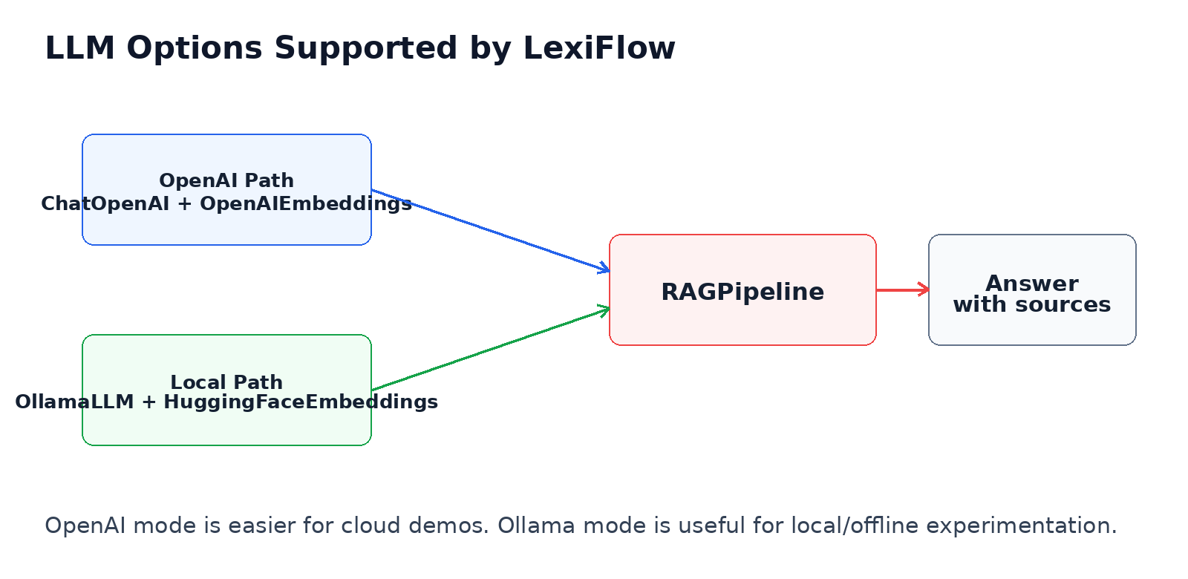
self.llm = OllamaLLM(model=self.model_name, base_url='http://localhost:11434')
self.embeddings = HuggingFaceEmbeddings(model_name='all-MiniLM-L6-v2')
self.retriever = self.vectorstore.as_retriever(search_kwargs={'k': 3})
self.chain = (
{'context': self.retriever | self._format_docs, 'question': RunnablePassthrough()}
| self.prompt
| self.llm
| StrOutputParser()
)

9. Deep Dive: advanced_features.py
advanced_features.py contains supporting features for a richer RAG application. It is useful for freshers to understand concepts beyond basic retrieval.
- ChatMemory
Stores recent conversations so follow-up questions can use previous context.
- HybridSearch
Combines semantic search from embeddings with keyword search.
- RoleBasedAI
Defines role-specific system prompts such as Customer Support, HR, Legal, Technical Assistant.
- SourceCitation
Formats sources so users can see where answers came from.

10. LangChain vs Direct OpenAI API Call
Area | Direct LLM Call | LangChain Approach
PDF loading | Manual implementation needed | PyPDFLoader / WebBaseLoader
Chunking | Manual text splitting | RecursiveCharacterTextSplitter
Embedding creation | Manual API calls | OpenAIEmbeddings / HuggingFaceEmbeddings
Vector search | Manual integration | FAISS vector store
Prompting | Manual string building | PromptTemplate / ChatPromptTemplate
Source documents | Hard to track | return_source_documents and metadata
Local LLM support | Separate implementation | OllamaLLM wrapper

11. End-to-End Example: My Product Is Not Working
Step | What happens
Customer asks | My product is not working.
app.py receives input | The Streamlit UI sends the question to RAGPipeline.query().
RAG retrieves policy | LangChain retrieves troubleshooting chunks from business rules.
Customer context added | Customer name, order ID, delivery days, warranty, previous tickets are added.
LLM generates answer | The LLM answers using retrieved policy and customer context.
UI displays result | Answer and sources are shown to the user.

12. Common Fresher Mistakes
- Thinking LangChain is an LLM. It is not. LangChain is a framework that works with LLMs.
- Thinking embeddings are readable text. They are numerical vectors.
- Thinking FAISS generates answers. It does not. FAISS retrieves similar chunks.
- Forgetting to chunk documents before embedding.
- Using too small top_k and missing relevant context.
- Confusing LangChain with LangGraph. Current LexiFlow uses LangChain.

13. Hands-On Exercise for Freshers
- Run streamlit run app.py.
- Upload customer_care_sample_policy.pdf.
- Select ORD-1001.
- Ask: My product is not working. What should I do?
- Open the sources section and observe the retrieved chunks.
- Change top_k and observe how retrieval changes.
- Study rag_pipeline.py query() method after running the demo.

14. Interview Questions and Answers
Q: What is LangChain?
A: LangChain is a Python framework for building LLM applications using documents, retrievers, vector databases, prompts, memory, tools, and LLMs.
Q: What is an LLM?
A: A Large Language Model is an AI model that understands and generates natural language.
Q: Why does LexiFlow use LangChain?
A: To implement RAG: loading documents, chunking, embedding, storing in FAISS, retrieving relevant content, and calling the LLM.
Q: What is the most important LangChain file in LexiFlow?
A: rag_pipeline.py.
Q: What is FAISS used for?
A: FAISS stores text embeddings and performs similarity search.
Q: What is an embedding?
A: A numerical vector representation of text.
Q: What is a retriever?
A: A component that fetches relevant document chunks for a user query.
Q: Does LexiFlow use LangGraph?
A: No. It uses LangChain and custom Python orchestration. LangGraph can be a future enhancement.

15. Summary
LangChain is the foundation of LexiFlow’s RAG capability. It connects policy documents, customer questions, embeddings, FAISS retrieval, prompt construction, and LLM response generation. For freshers, the learning path should be: understand LLM, understand RAG, understand LangChain components, then study app.py and rag_pipeline.py together.
One-line explanation
LangChain helps LexiFlow convert company knowledge into accurate, source-grounded customer support answers.

